- Ladder logic blocks

Ladder Logic software supports following blocks

Contact blocks
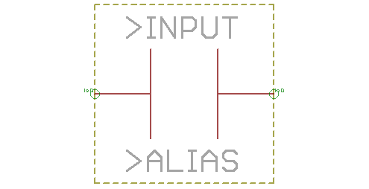 | Normally open contact
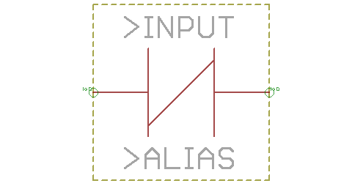 | Normally closed contact,  “not” contact
Coils
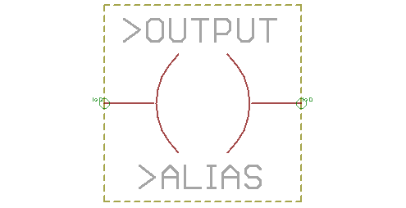 | Normally de-energized coil
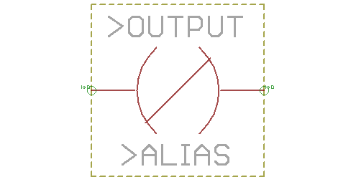 | Normally energized coil,  “not” coil
Timers
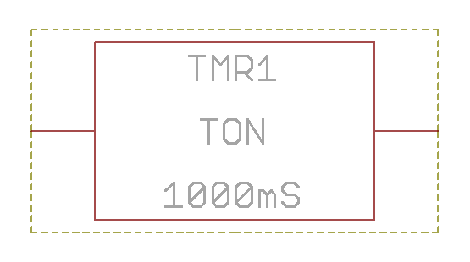 | On-delay timer
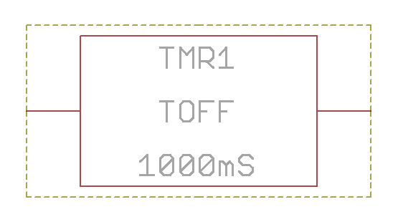 | Off-delay timer
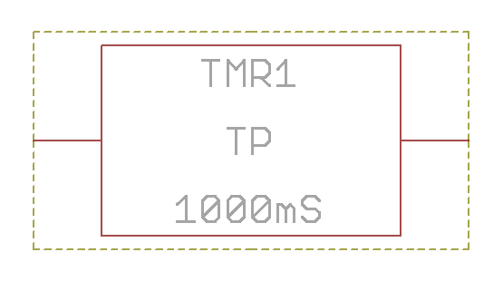 | Pulse timer
Latch
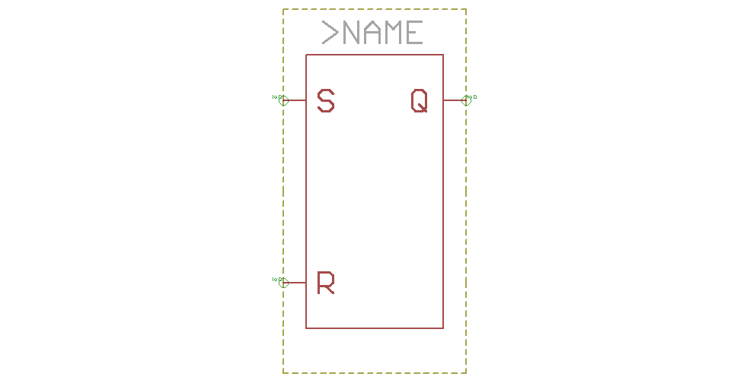 | Latch

- Ladder example 1 – motor control latch circuit

Description: There are two keys for motor control – key for motor start (at input X0) and another one for stop (at input X1). Motor relay connected to output Y0. Momentary pressing of start key starts motor, momentary pressing of stop key stops motor.
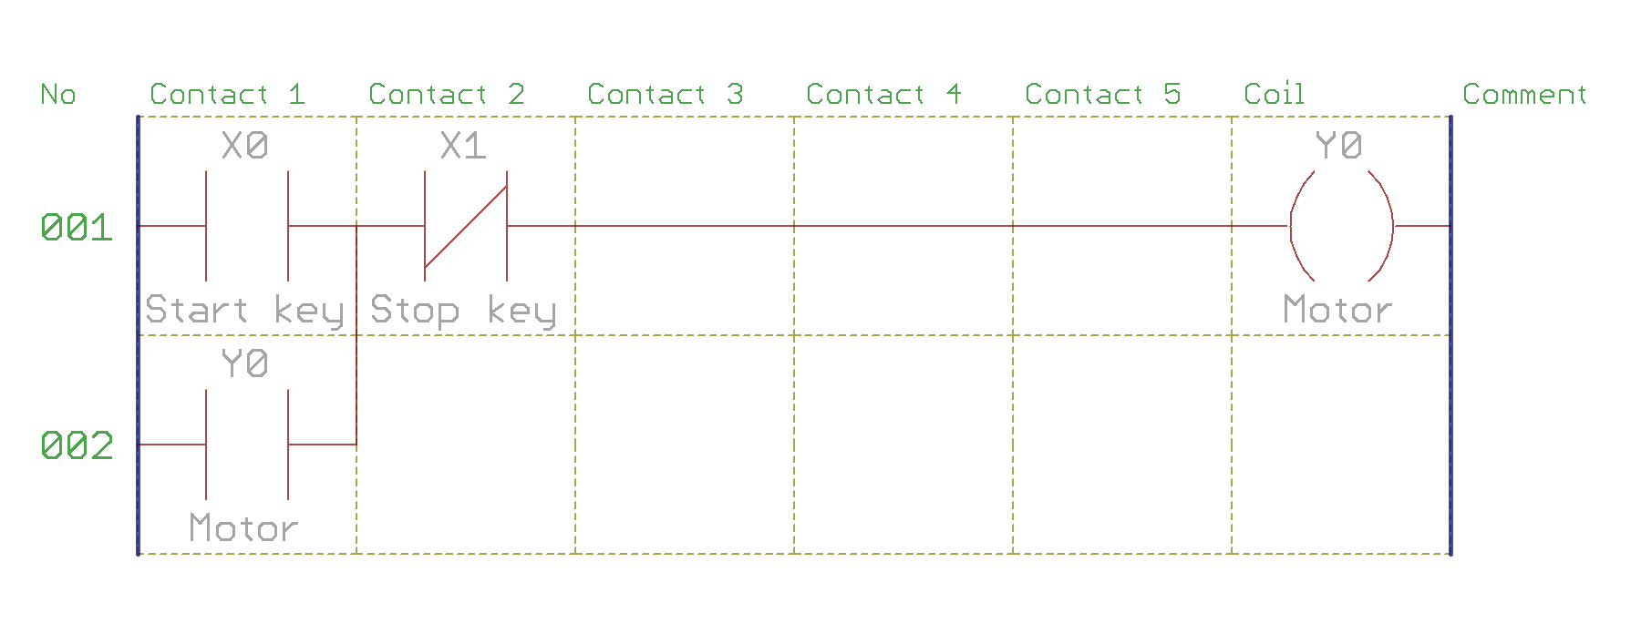
Translated code is (in loop(){...})

…
/Rung 1
in(X0);
or(Y0);
andNot(X1);
out(Y0);
…

And solution using latch block
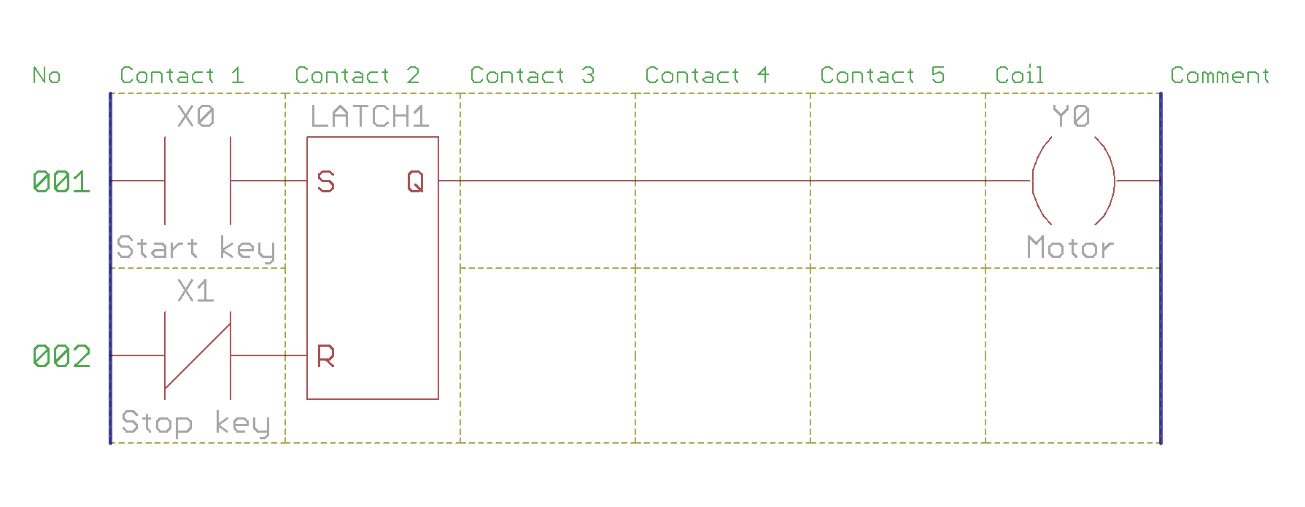
Translated code
…
//Rung 1
in(X0);
latch(Y0,X1);
…
- Ladder example 2 – flashlight

Description: Control key pressing on X0 starts lamp on Y0 flashing with period of 1 second, and another pressing stops this.

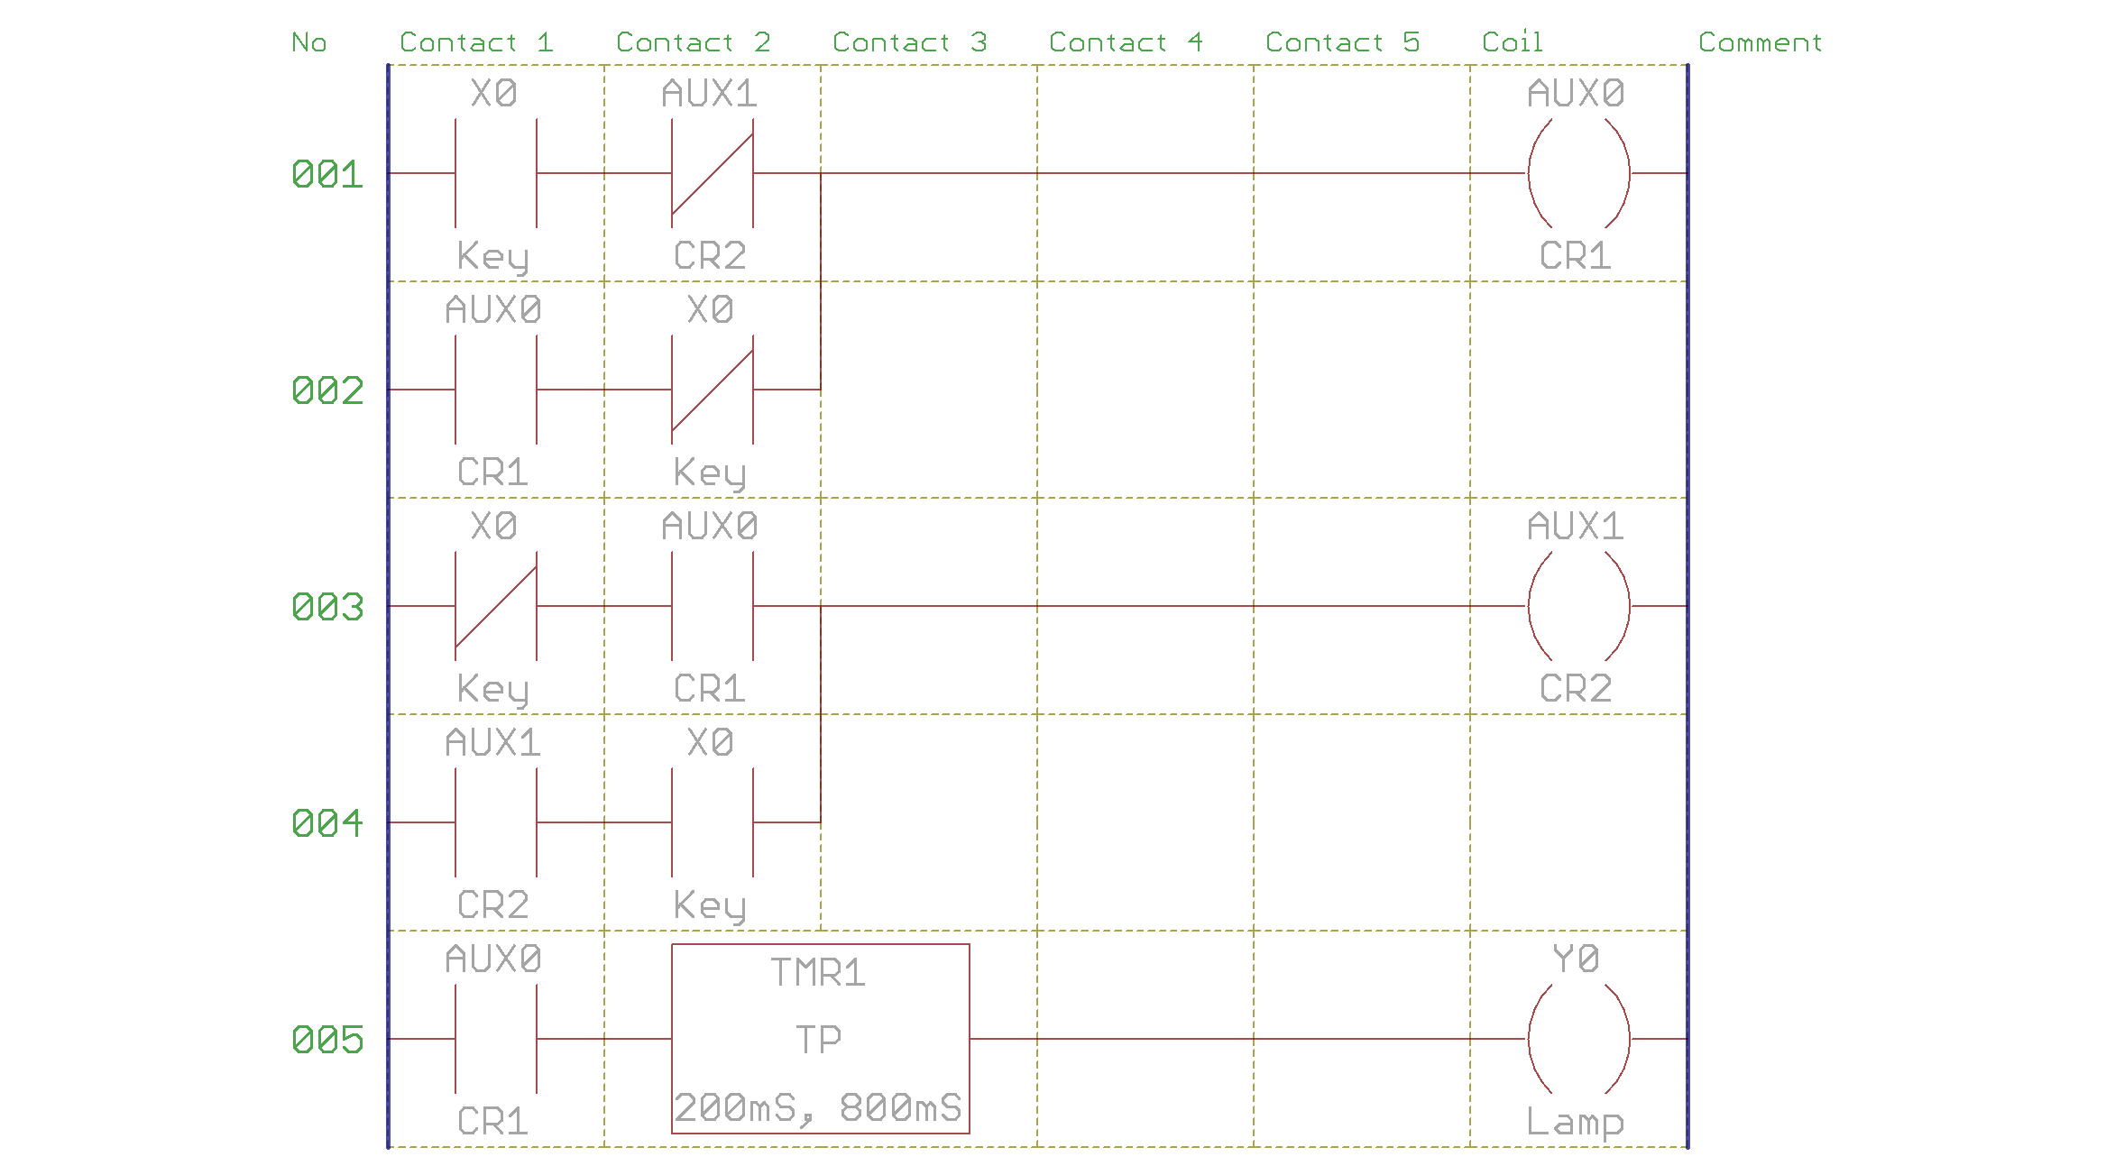
Translated code is (in loop(){...})
…
unsigned int AUX0, AUX1; //aux variables
unsigned int CLR001, CLR003; //addition variables for lines
unsigned long TMR1=0, TMR2=0; //timer variables
…
//Rung 1
in(X0);
andNot(AUX1);
out(CLR001);
in(AUX0);
andNot(X0);
or(CLR001);
out(AUX0);

//Rung 2
inNot(X0);
and(AUX0);
out(CLR003);
in(AUX1);
and(X0);
out(AUX1);

//Rung 3
in(AUX0);
timerPulse(TMR1, 200, TMR2, 800);
out(Y0);

